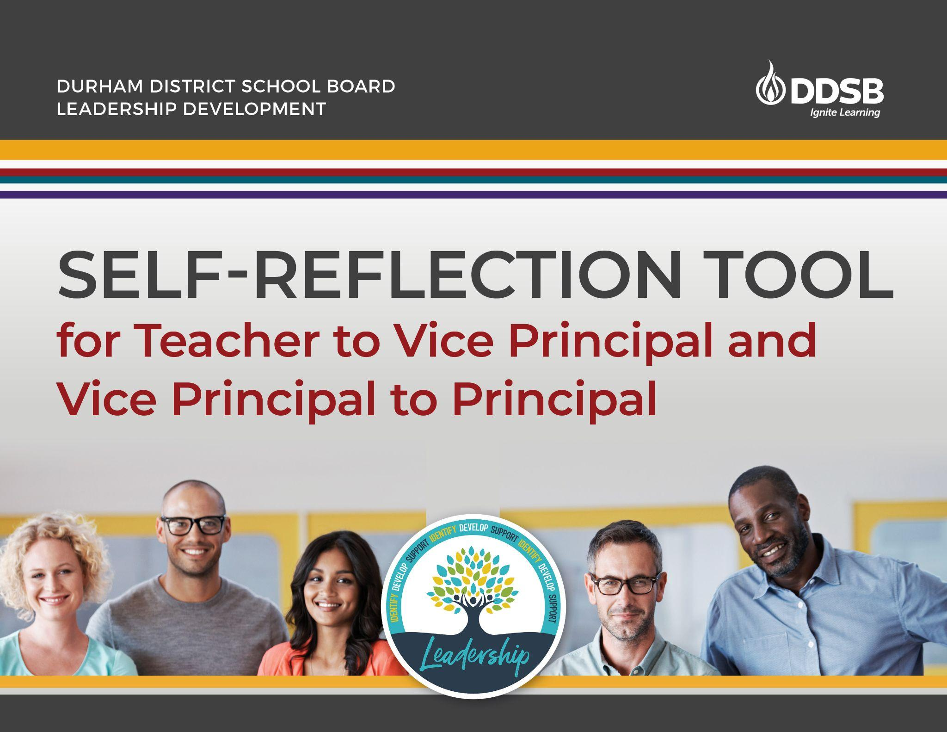

DRAFT Self-Reflective Tool for the Promotion Process (Teacher to VP and VP to P)
*This draft document will be reviewed and updated for Winter 2025
If you wish to complete this electronically please download a copy.

DDSB Guiding Principles:
We recognize and uphold distinct Indigenous Rights.
We affirm and uphold human rights.
We care about and strive to know each other.

Purpose of this self-reflection tool: To self-assess leadership readiness. Utilize this tool to determine whether you are ready for the next step in your leadership journey. This tool will help you reflect on your leadership and prepare you for a conversation with your supervisor(s). Consider gathering 2-3 artifacts that reflect your leadership work. You are encouraged to share this in conversation with your supervisor for feedback.

Considerations as you work through this document/tool:
- Consider current and relevant examples, where possible;
- Consider all members and partners of a school community;
- Make notes in the right hand column for reference
- Engage your supervisor with this tool in conversation and to identify growth opportunities (you will not submit this doc to supervisors);
- Items highlighted in gray are geared more towards reflection for VP to P.

LEADERSHIP DOMAINS - Anti-Oppressive Leadership, Direction and Vision, Knowing and Caring About People, Meaningful Learning, Moving Your School Forward, and Responsibility and Accountability for Learning.

Thank you to the team of administrators who worked on creating this leadership self-reflection tool in collaboration with the Leadership Department.

SELF-ASSESSING LEADERSHIP READINESS USING 6 DOMAINS AND THEIR COMPETENCIES

Anti-Oppressive Leadership | Indicators and Questions for Reflection | Reflect on work that you have done and how this is an example of leadership. Jot down notes for your own self-assessment of readiness.
Competencies
Modeling an anti-oppressive leadership stance and honouring every individual’s identity and inherent dignity | What steps have you taken to ensure that identities of all students and staff are valued and reflected?
 | Are you able to hold conversations about identity, race, marginalization, power, and privilege with critical friends, staff, students, and families?
 | Are you able to effectively understand and interpret various situations/issues and respond appropriately?
 | What actions have you taken to disrupt and dismantle oppressive practices?
 | How do you centre student voice?
 | How have you developed your habits of mind in applying anti-oppressive practices to decision-making?
 | How have you used student voice to incorporate their identities and lived experiences to improve student achievement?
 | What steps have you taken to enact the Truth and Reconciliation Commission of Canada Calls to Action?
Anti-Oppressive Hiring Practices and Opportunities | How have you supported and encouraged student and staff leaders in your building whose identities are or have been historically marginalized?
Anti-Oppressive Hiring Practices and Opportunities | How do you provide leadership opportunities to staff whose identities are or have been historically marginalized?
Anti-Oppressive Hiring Practices and Opportunities | VP-P. Hiring practices - how do you recruit and select teachers who have the interest and capacity to further the school’s vision and goals?

Direction and Vision | Indicators and Questions for Reflection | Reflect on work that you have done and how this is an example of leadership. Jot down notes for your own self-assessment of readiness.
Competencies
Demonstrate an understanding of school leadership and student achievement | Do you understand what it means to be an anti-oppressive leader in the classroom, our school, and our system? What does it look like?
 | What are you doing to support equitable outcomes for all students?
 | How have you challenged anti-oppressive practices to promote justice and fairness? How do you know it was impactful in a positive way?
Engagement, collaboration, and communication with students, staff, families, and communities | Describe activities that you have implemented to build community engagement and specifically address those who are not engaged in school?
 | How have you worked alongside others to gather the ‘voice’ of people, including those who may not come to the table?
 | What are you doing in a meaningful way to create opportunities to make connections with various members of the school community?
Build and communicate a shared vision | How do you and the school team support the school learning plan and the goals within it?
Build and communicate a shared vision | How do you ensure you have gathered voices from those currently and historically marginalized to build and communicate the goals?
Build and communicate a shared vision | How do you model commitment to the school’s vision, values and practices? Include reference to key policies, the Mental Health and Well-Being Action Plan and the Multi-Year Strategic Plan.

Knowing & Caring About People | Indicators and Questions for Reflection | Reflect on work that you have done and how this is an example of leadership. Jot down notes for your own self-assessment of readiness.
Competencies
Develop and leverage trusting relationships to develop, grow, and engage staff, students, and community | What strategies do you employ to develop and maintain relationships with staff, students, parents/caregivers, and school community?
 | How are you deepening and extending your learning about building trusting relationships?
 | How are you fostering relationships that promote an inclusive and safe environment where staff, across all roles within your school team, voluntarily bring their voice forward and share about themselves?
 | What work with staff, students, families/parents/caregivers, and communities have you led, or participated in to build engagement?
 | How do you build upon and respond to students and staff members’ unique needs and expertise, valuing individual identities and lived experiences?
 | What is your awareness of and how are you challenging power and privilege, as well issues connected to oppression?
 | How do you manage challenging conversations/topics with staff, students, families, and community members whose identities are or have been historically marginalized, as well as those who have not?
 | How do you recognize your own emotions and responses during these challenging conversations/topics?
 | How do you build capacity in your staff and encourage them to take on leadership roles?
 | VP-P. How have collaborated to support admin partners to improve their leadership and build more effective relationships with others in the school community (ie. union rep, advocates, parents, etc.)?
Actively participates, creates and sustains a professional learning community | How do you support growth in the professional capacities of you and all school staff, in the areas of human rights, Indigenous education, and anti-oppression?
 | How do you include staff across all roles in school teams?
 | What considerations around culturally relevant supports and learning opportunities have you thought about and implemented?
 | How have you facilitated team effectiveness and ensured meaningful collaboration?
 | How do you effectively collaborate with those who are more hesitant than others?
Connecting students, staff, and families to each other and to supports and resources within and beyond the school walls | What partnerships have you actively worked to form, particularly to support historically marginalized, underserved and/or underrepresented students, staff, and families?
 | How have you and the school community created safe and caring learning environments where people can thrive?
 | How have you worked alongside others to support the everyday mental health and well-being, as well as the physical health of others?

Meaningful Learning | Indicators and Questions for Reflection | Reflect on work that you have done and how this is an example of leadership. Jot down notes for your own self-assessment of readiness.
Competencies
Providing instructional support around anti-oppressive practices, the instructional program, and current assessment practices | How do you ensure the following is happening in your building and how do you oversee the instructional program and work with your staff on instructional improvement?  - creating a culture of high expectations for all  - knowledge of triangulation of data  - UDL  - preparation/collaboration time for staff
 | What steps do you take to observe classroom instruction, provide feedback, and conduct performance appraisals?
 | What professional development have you led? What impact has it had?
Mentors new teachers/ teacher candidates and is a role model for colleagues | Have you supported a teacher candidate or have you informally mentored colleagues (i.e. like grade teacher, chair, department head, etc.)?
 | What work with the NTIP program have you done?
Demonstrates a sound understanding, advocacy, and supports for diverse learners | How do you support, measure, and monitor the growth and successes of students?
 | How are you centering students and matching educational experiences to their interests and goals to prepare them for a changing world?

Moving Schools Forward | Indicators and Questions for Reflection | Reflect on work that you have done and how this is an example of leadership. Jot down notes for your own self-assessment of readiness.
Competencies
Building Collaborative Cultures | What work with staff students and communities have you led, or participated in to build a collaborative culture?
Building Collaborative Cultures | When building a collaborative culture, what considerations based on identity and lived experiences are you thinking about?
Building Collaborative Cultures | What is your understanding of biases and stereotypes and how do you incorporate this into your collaborative work?
Building Collaborative Cultures | How have you fostered opportunities to meet, learn from and inspire others?
Understanding of our Indigenous Education, Human Rights, and Safe and Respectful Workplace and Harassment Prevention Policies (the “Big 3”) | What learning have you done in these three areas and how have you supported the learning of others?
 | How have these three policies impacted your practice?
 | What professional development have you led in these 3 areas?

Responsibility and Accountability for Learning | Indicators and Questions for Reflection | Reflect on work that you have done and how this is an example of leadership. Jot down notes for your own self-assessment of readiness.
Competencies
I engage staff in analyzing data on the learning progress of all students, using high quality data | How am I deepening and extending learning and supporting all learners in the classroom, including the underserved?
 | How do I help staff make connections between school goals and ministry goals to strengthen commitment to our school learning plan?
I promote collective responsibility and accountability for student achievement  and well-being. | How do you collectively monitor and share widely the progress and next steps in student learning and school improvement?
 | VP-P. How are you providing feedback and support to improve school leadership and move the School Learning Plan forward?

Final Questions for Reflection:
What are my areas of strength and areas of growth?
Am I emotionally (psychologically, cognitively, and socially) ready for a leadership role?
Do I feel ready to proceed in the promotion process?
Have I received and actioned feedback from my supervisor or administrative partner?
What are my next steps and timelines?
Who will support me in these steps?

Optional Final Product to Share Readiness:
Consider sharing an artifact or creating a one page (maximum of two pages) document/poster/chart/slide to share your leadership journey with your Principal/Superintendent during your school visit. A reminder that this self-reflection tool does not need to be shared with anyone as it’s for your own personal use.

We would like to acknowledge the TDSB Equity Leadership Competencies, the YRDSB Leadership Framework, the Ontario Leadership Framework, and the PDSB Equity Leadership Competencies which were used as supportive resource documents.



